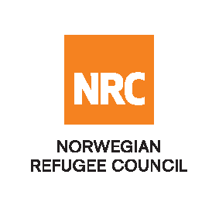
Tender Advertisement

The Norwegian Refugee Council (NRC) is a non-governmental, humanitarian organization with 60 years of experience in helping to create a safer and more dignified life for refugees and internally displaced people.
NRC advocates for the rights of displaced populations and offers assistance within the Shelter, Education, Emergency food security, and Legal assistance and Water, sanitation and hygiene sectors.

No | ITB Reference | Description | Remarks | Deadline for submission of bids
1 | FWA-2025-CXB-0683 | Long-Term Framework Agreement (FWA) for the supply of Education Kits | The quoted price must be valid for at least one year. | 17th December 2025 (5.00 PM, Bangladesh local time)

The Norwegian Refugee Council (NRC) Office in Bangladesh invites eligible and interested bidders to participate in this ITB.
REMARK: The Tender can be downloaded from the following link:

ITB-2025-CXB-0683 - Education Kit.docx

If anyone faces challenges downloading from the link, send an email to bd.procurement@nrc.no for a copy of the tender package at least five working days before the submission deadline.

Manner of Submission:
  - By hand in a sealed envelope to the NRC office located: 3rd Floor, Sayeman Heritage Residence, Building - 2, Old Sayeman Road, Baharchara, Cox’s Bazar, Bangladesh – 4700
or
  - By email to the dedicated and secure email address: bd.bids@nrc.no (offers received on other email addresses will not be considered)
Submissions should be made before the Closing date & time mentioned above. Companies that do not submit their quotation by this deadline will not be considered. If you have any questions for the ITB, please send them via email to bd.procurement@nrc.no not later than five working days before the deadline.
- Please indicate the subject of the e-mail letter: 0683.CXB. E-mails with a different subject line (or without a subject line) may not be considered.
- The supply must meet all the requirements set out in the Request for Quotation (attached) and be accompanied by documents stipulated in ITB. Please send scanned copies of these documents together with the completed ITB.
- The proposal must be submitted in the set non-editable format:
- scans of all pages of the proposal, either in separate .jpg files, OR
- separate/single .pdf files containing scanned pages, OR
- electronically signed PDF document with signature and seal (when applicable).
- The size of all attachments should exceed 20 Mb for one email. You can send several emails, in this case, please indicate the following subject:
- - 0683.CXB - 1/2; 0683.CXB - 2/2 in case you need to send two emails in total;
- - 0683.CXB - 1/3; 0683.CXB - 2/3; 0683.CXB - 3/3 in case you need to send three emails in total;
- Submission of all or part of the proposal in a freely editable format (Word, TXT, etc.) is NOT ALLOWED.

Thank you for your participation in the tender process

